# ASSESSMENT 3 – GUIDE

1. Go to website - <https://start.spring.io/>

Choose Java , Gradle and version 8 and add below 4 dependencies

H2,Lombok,Spring Web, Spring data JPA

Extract the downloaded project and store the folder in below path

C:\Users\313477\IdeaProjects

Open the project via Intellij and then add

Dockerfile (project root directory)

<https://raw.githubusercontent.com/VaradharajanThiagarajan/SelfGuest/master/Dockerfile>

README.md (project root directory)

<https://raw.githubusercontent.com/VaradharajanThiagarajan/SelfGuest/master/README.md>

Heroku.yml (project root directory)

https://learn-2.galvanize.com/cohorts/2560/blocks/1164/content_files/units/04_Deployment/06-deployment-zoo.md

git remote add origin https://github.com/VaradharajanThiagarajan/playlistapp.git

git branch -M master

git push -u origin master

1. Create new repository (without Readme) in GITHUB from the below website

https://github.com/VaradharajanThiagarajan?tab=repositories

1. Then get into the C:\Users\313477\IdeaProjects\SelfGuest - where selfguest is sample project name and right click and select Git bash and issue below commands

git init

git add -A

git commit -m “Initial commit”

git remote add origin <https://github.com/VaradharajanThiagarajan/PracticeTest1.git>

git branch -M master

git push -u origin master

Assessment group 4

Git clone cottonfactory project and open in intellij – for cloning use the main branch

Git checkout -b “langoliers”

Build the gradle

Edit the readme.txt

Git commit -am “readmeupdated”

Git ppush

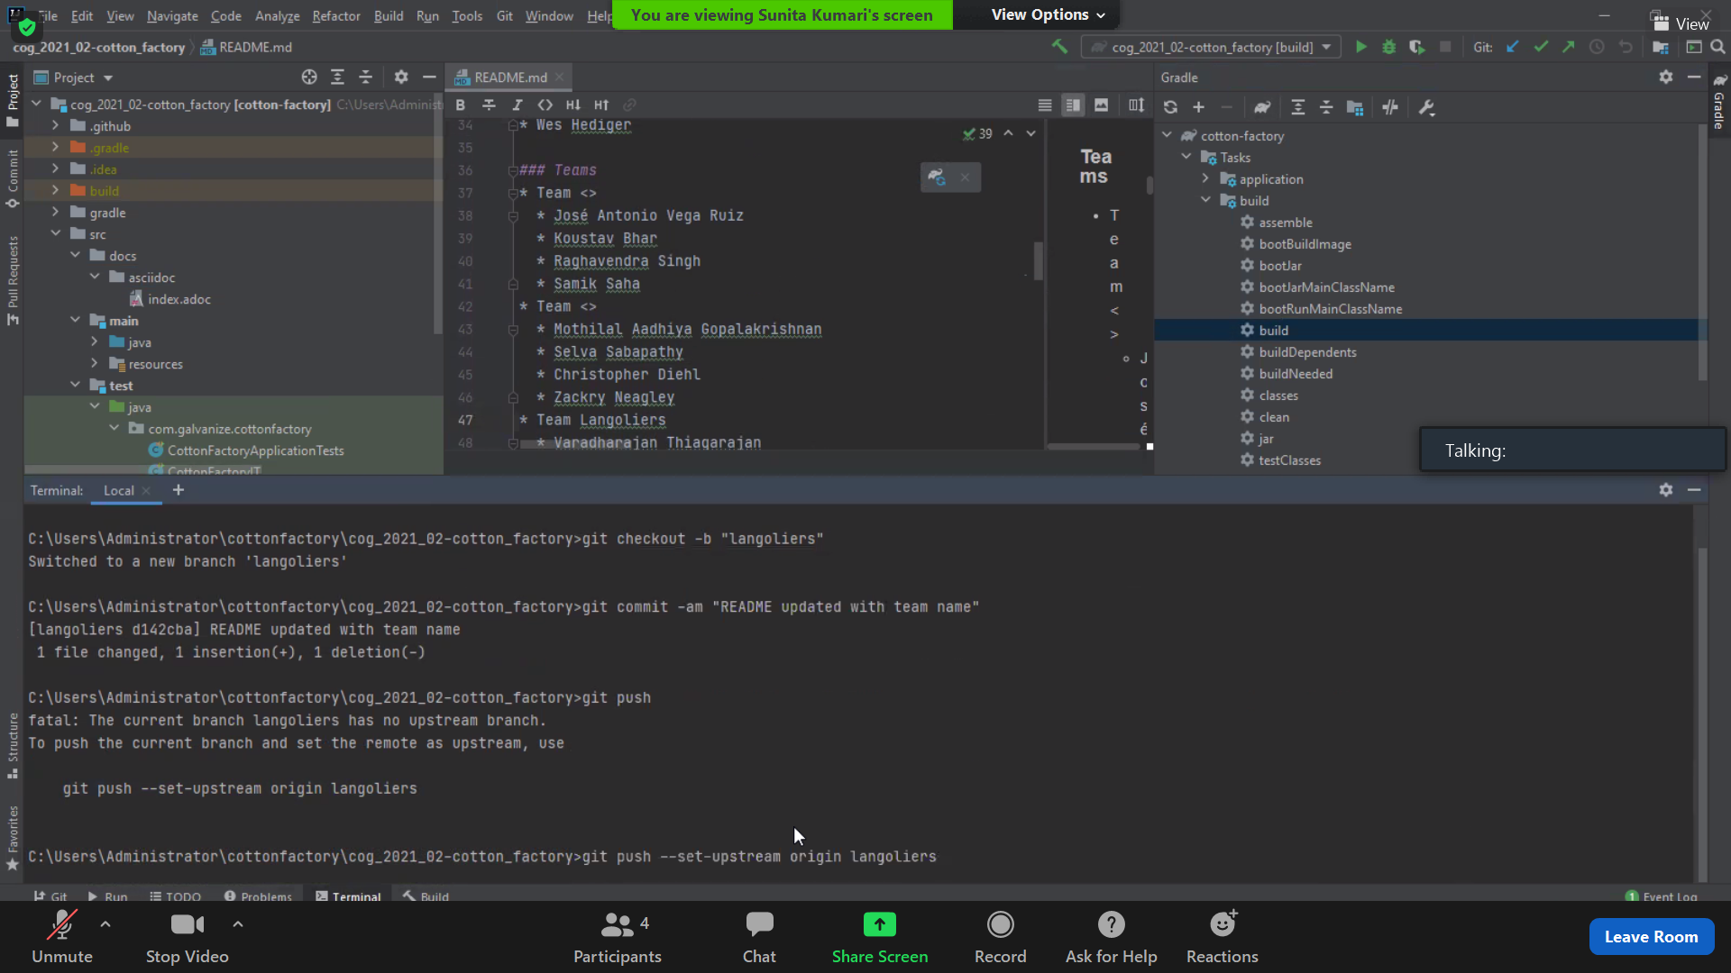

Go to github reporsity

Click pull request

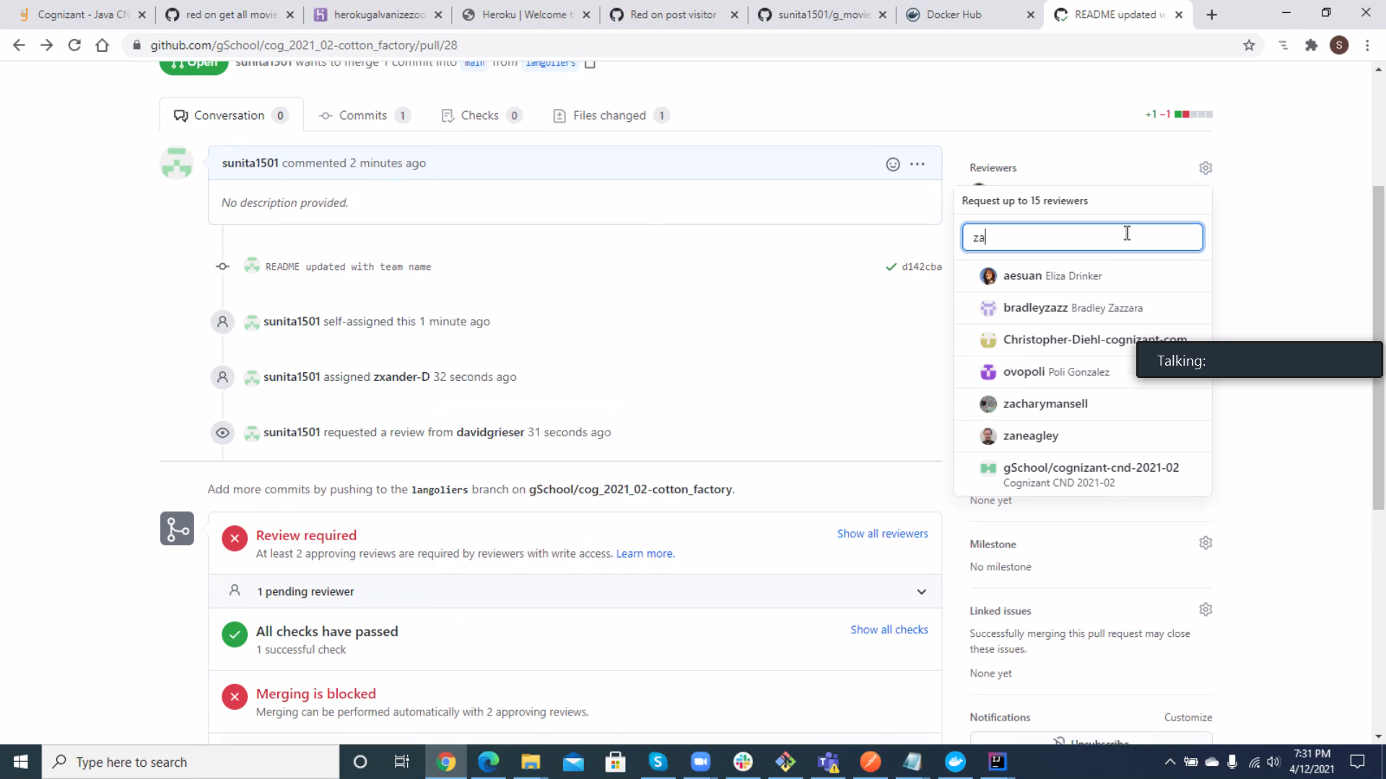

Used files changed tab and approved the review

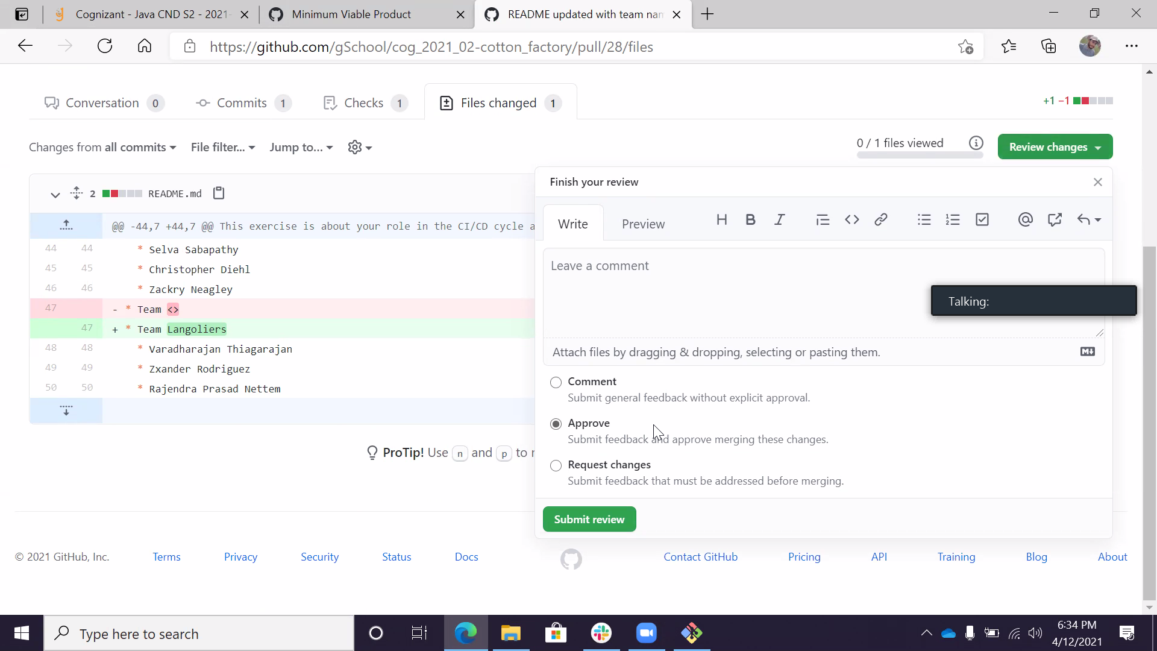

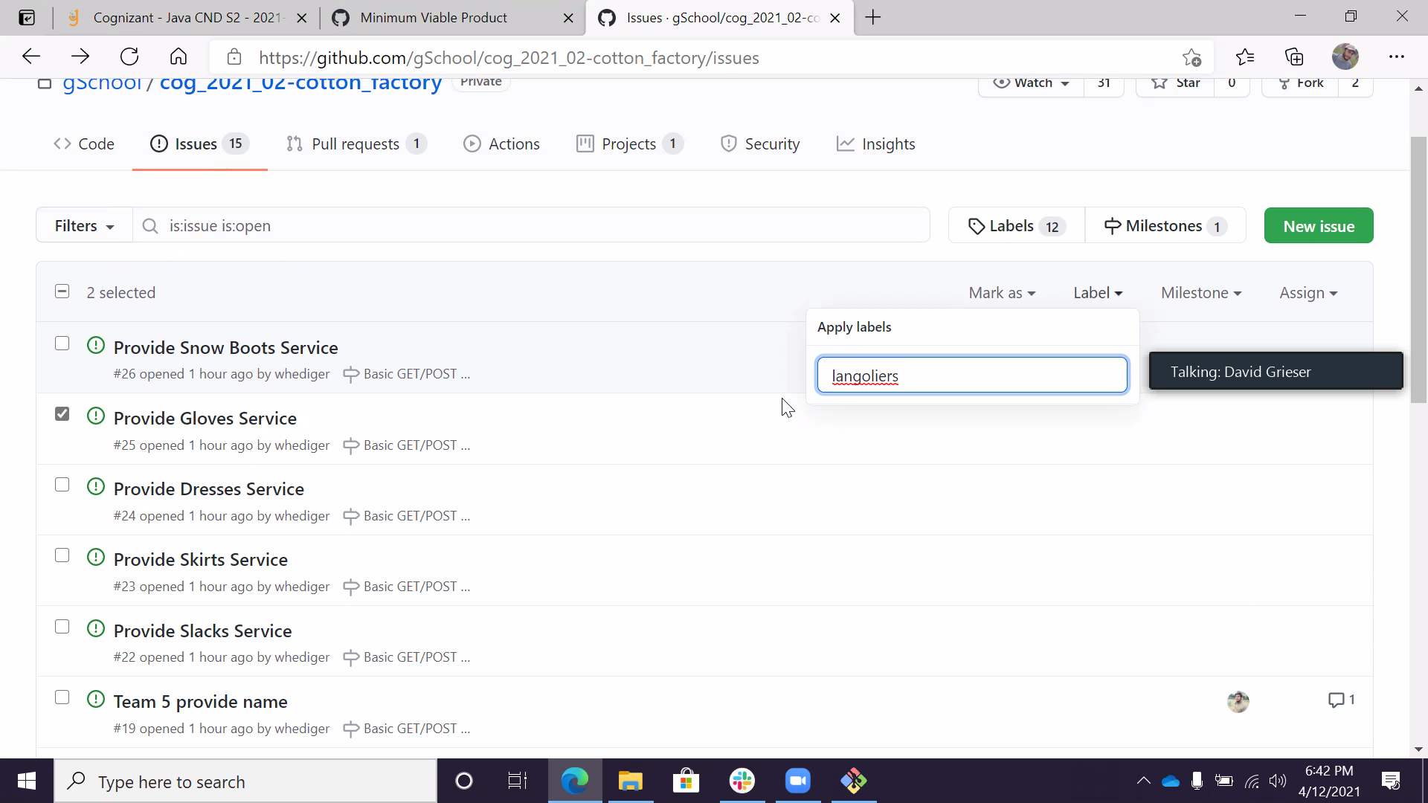

Kanban board

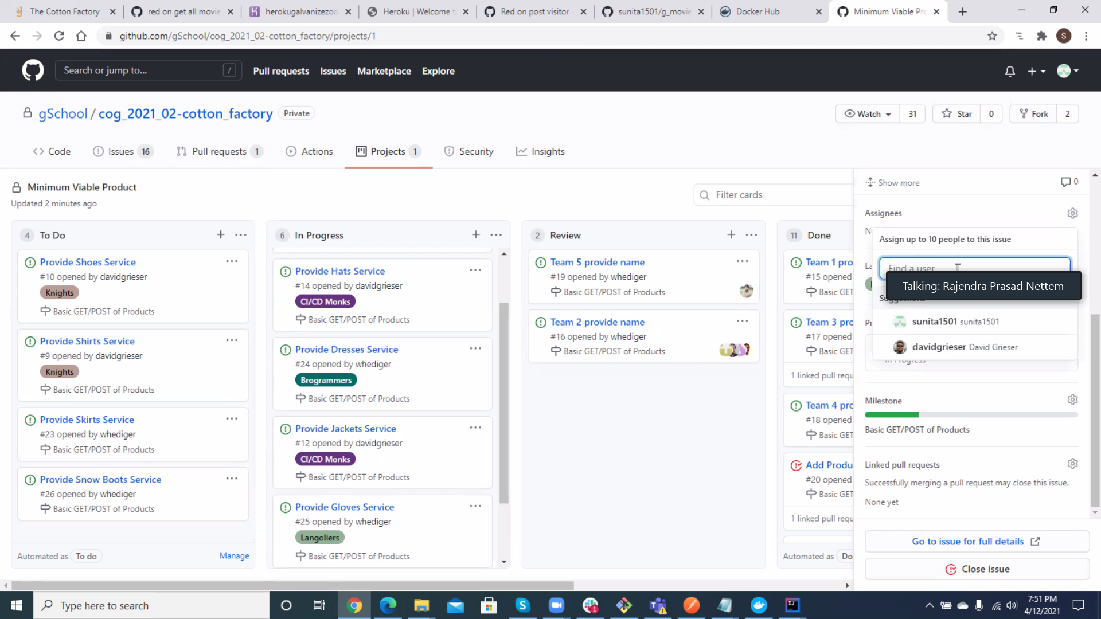

Git clone

<https://github.com/gSchool/cog_2021_02-cotton_factory.git>

git pull – to verify latest version is there

git checkout -b “feature/getgloves”

git merge main

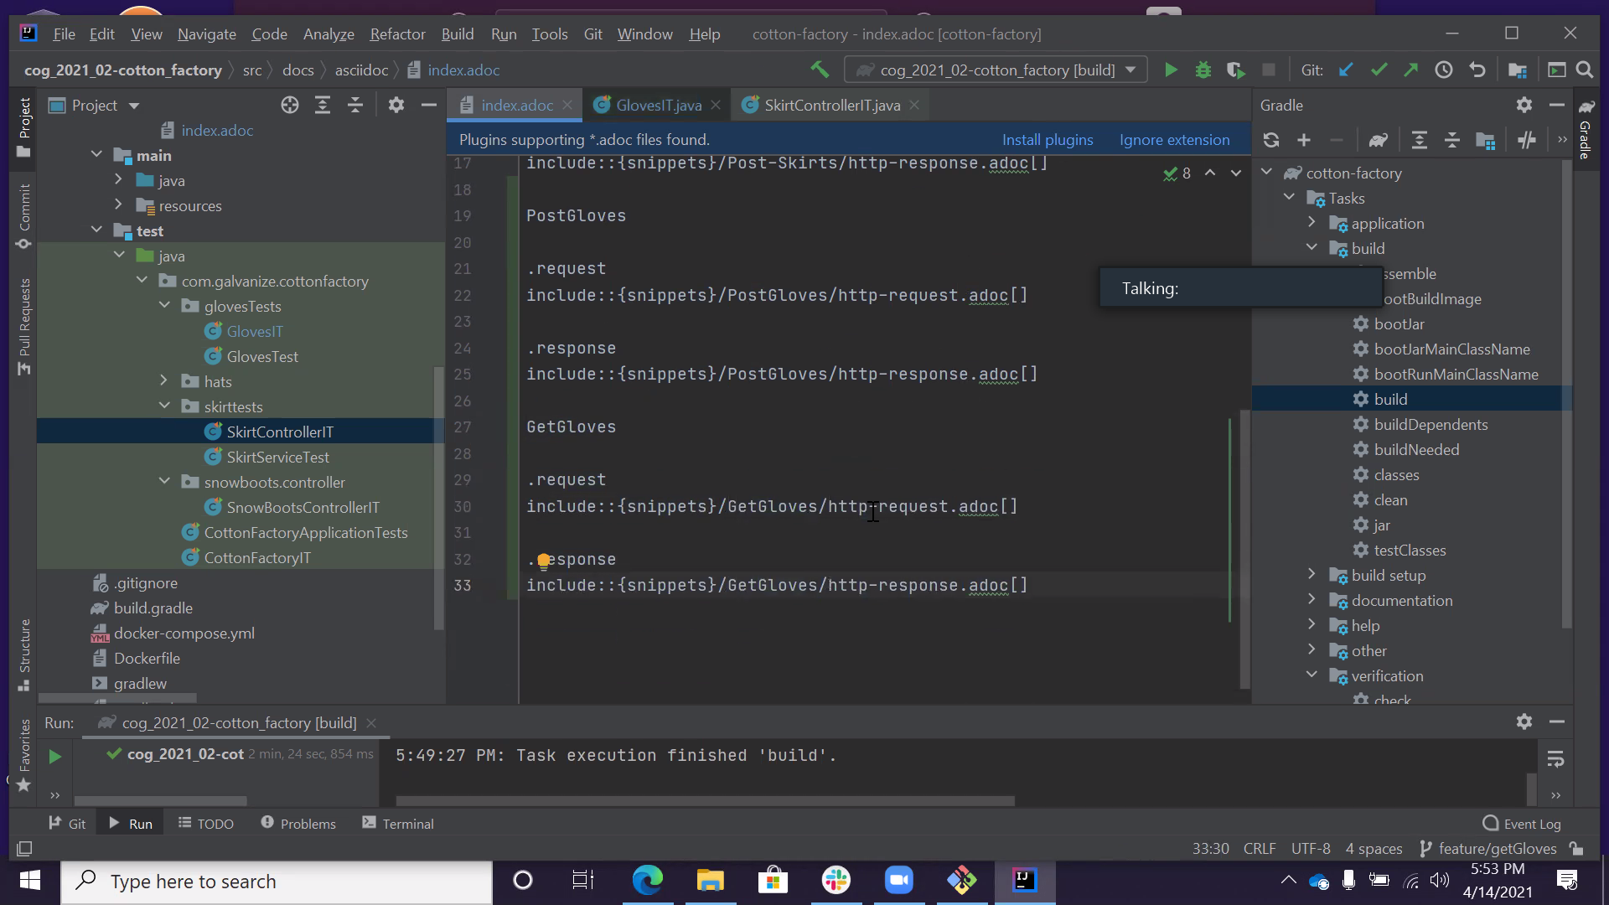

To ensure my branch is upto date with the main

Steps to ensure we have our branch updated with the main

Method 1

1. Git checkout main
2. Git pull
3. Git check branch
4. Git merge main

Current status of the main branch and applies it into the branch

It does the commit as well

Method 2

1. Git checkout main
2. Git pull
3. Git check branch
4. Git rebase main

(this is longer process)

Inserts every entry from the main and applies the changes to the branch

After merging

Git checkout main

Git pull

git branch -d feature/getGloves

git branch -a – get list of branches

then again now create new brach for next task

git checkout -b "feature/getGloveByName"

git push --set-upstream origin feature/getGloveByName

git merge main

vim command editor

ESCAPE and :WQ

Click merge pull request button

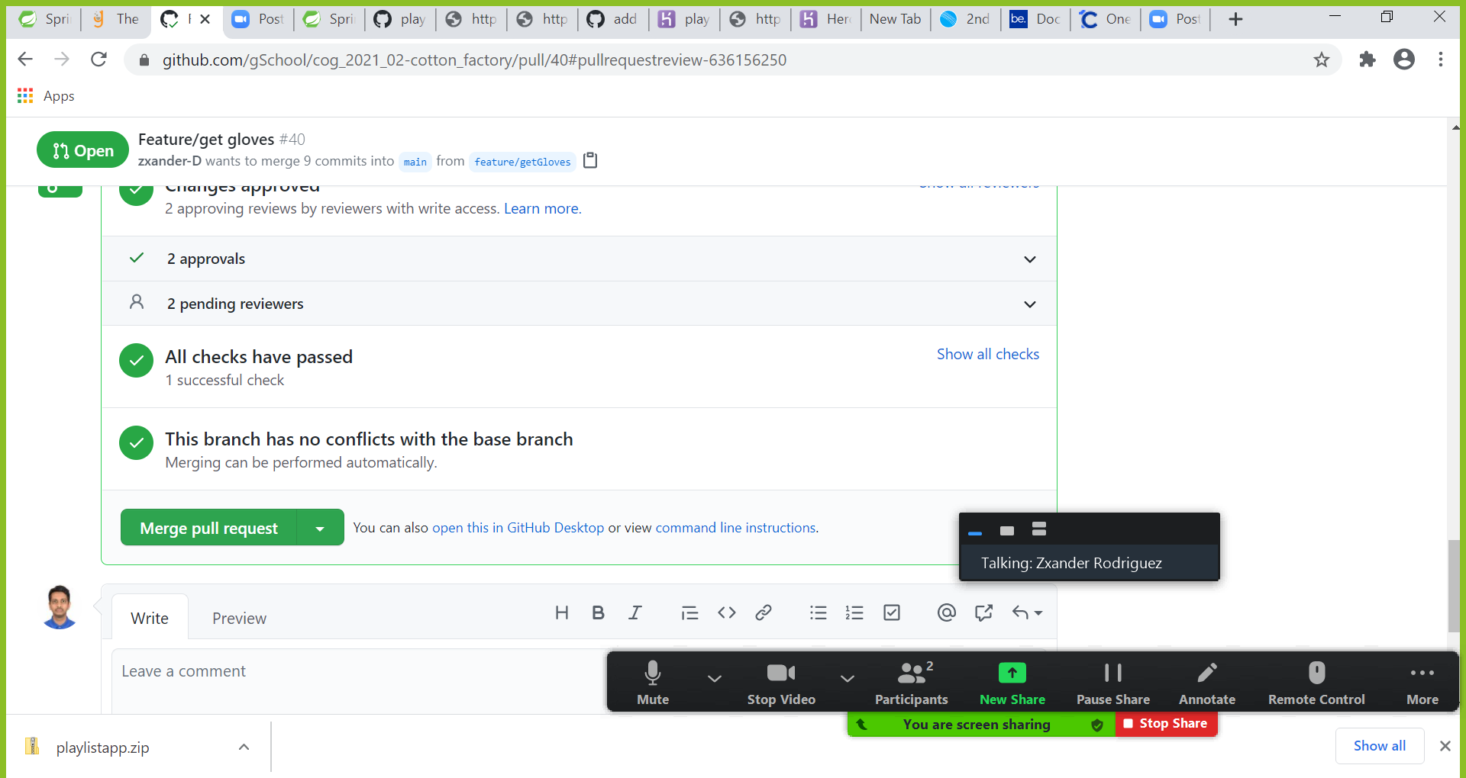

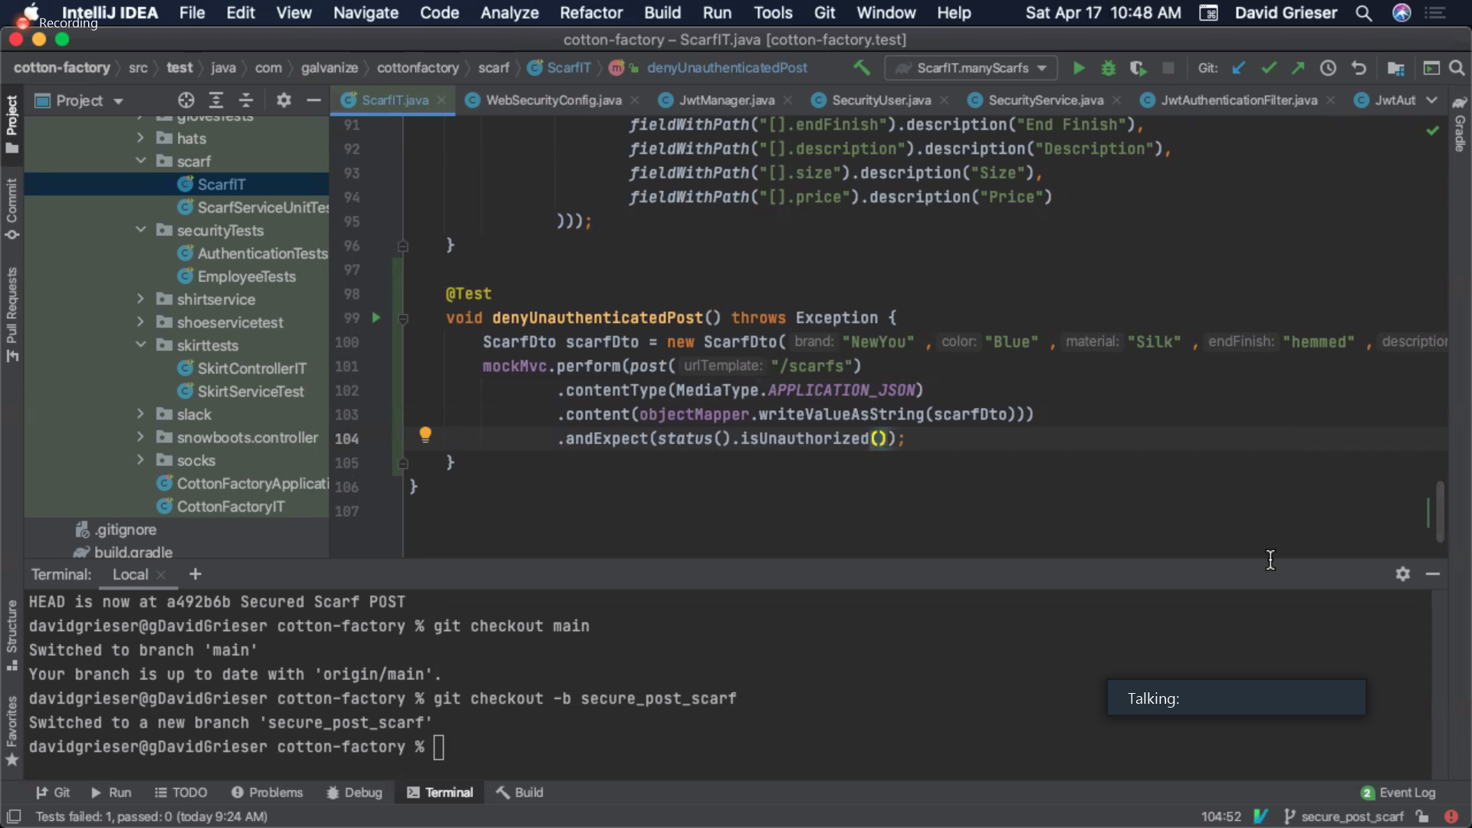

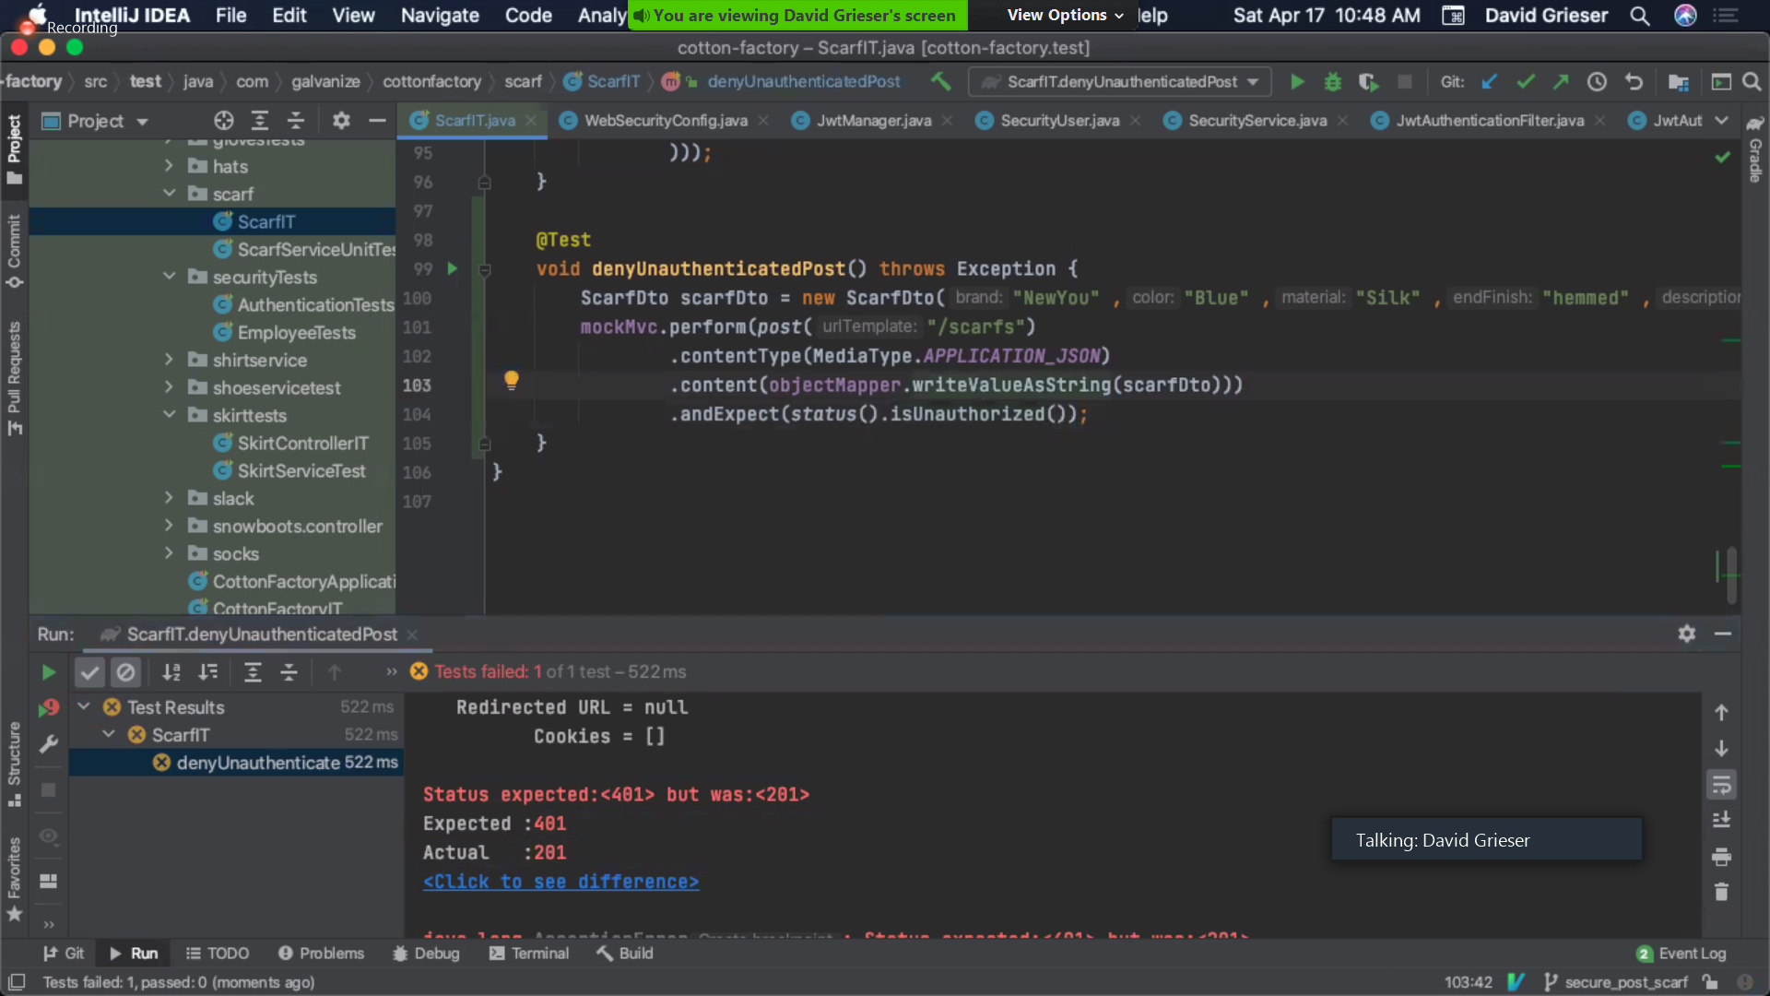

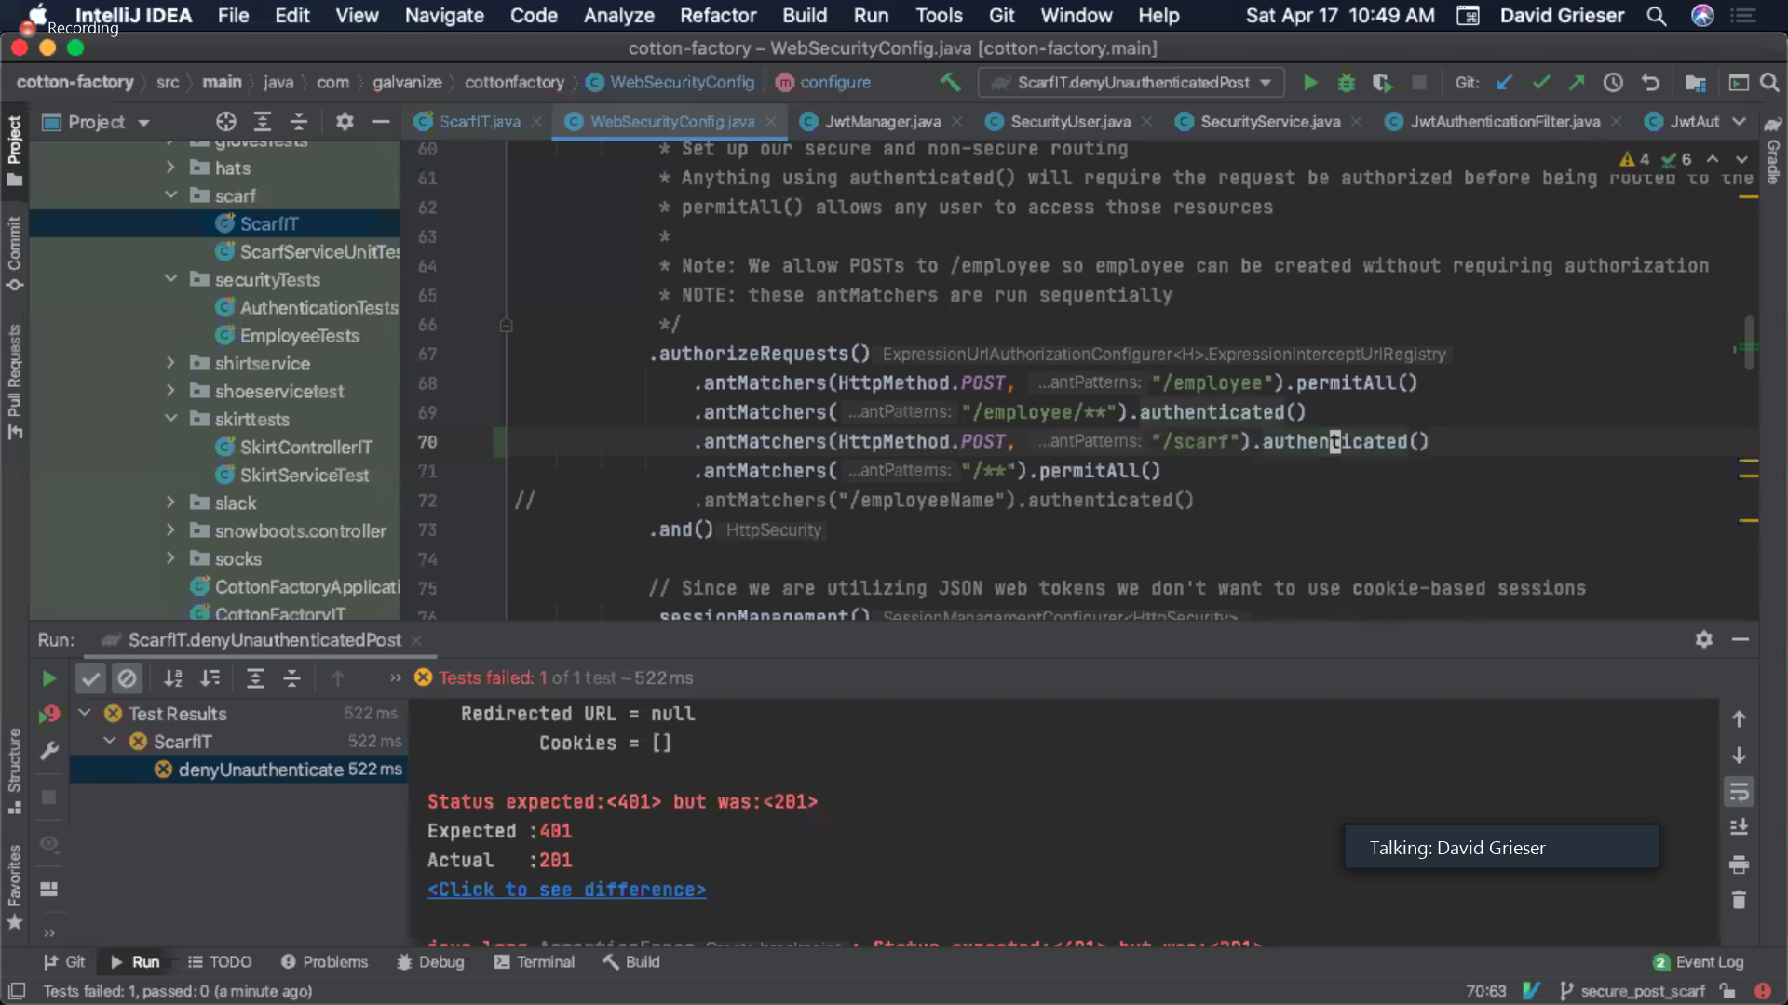

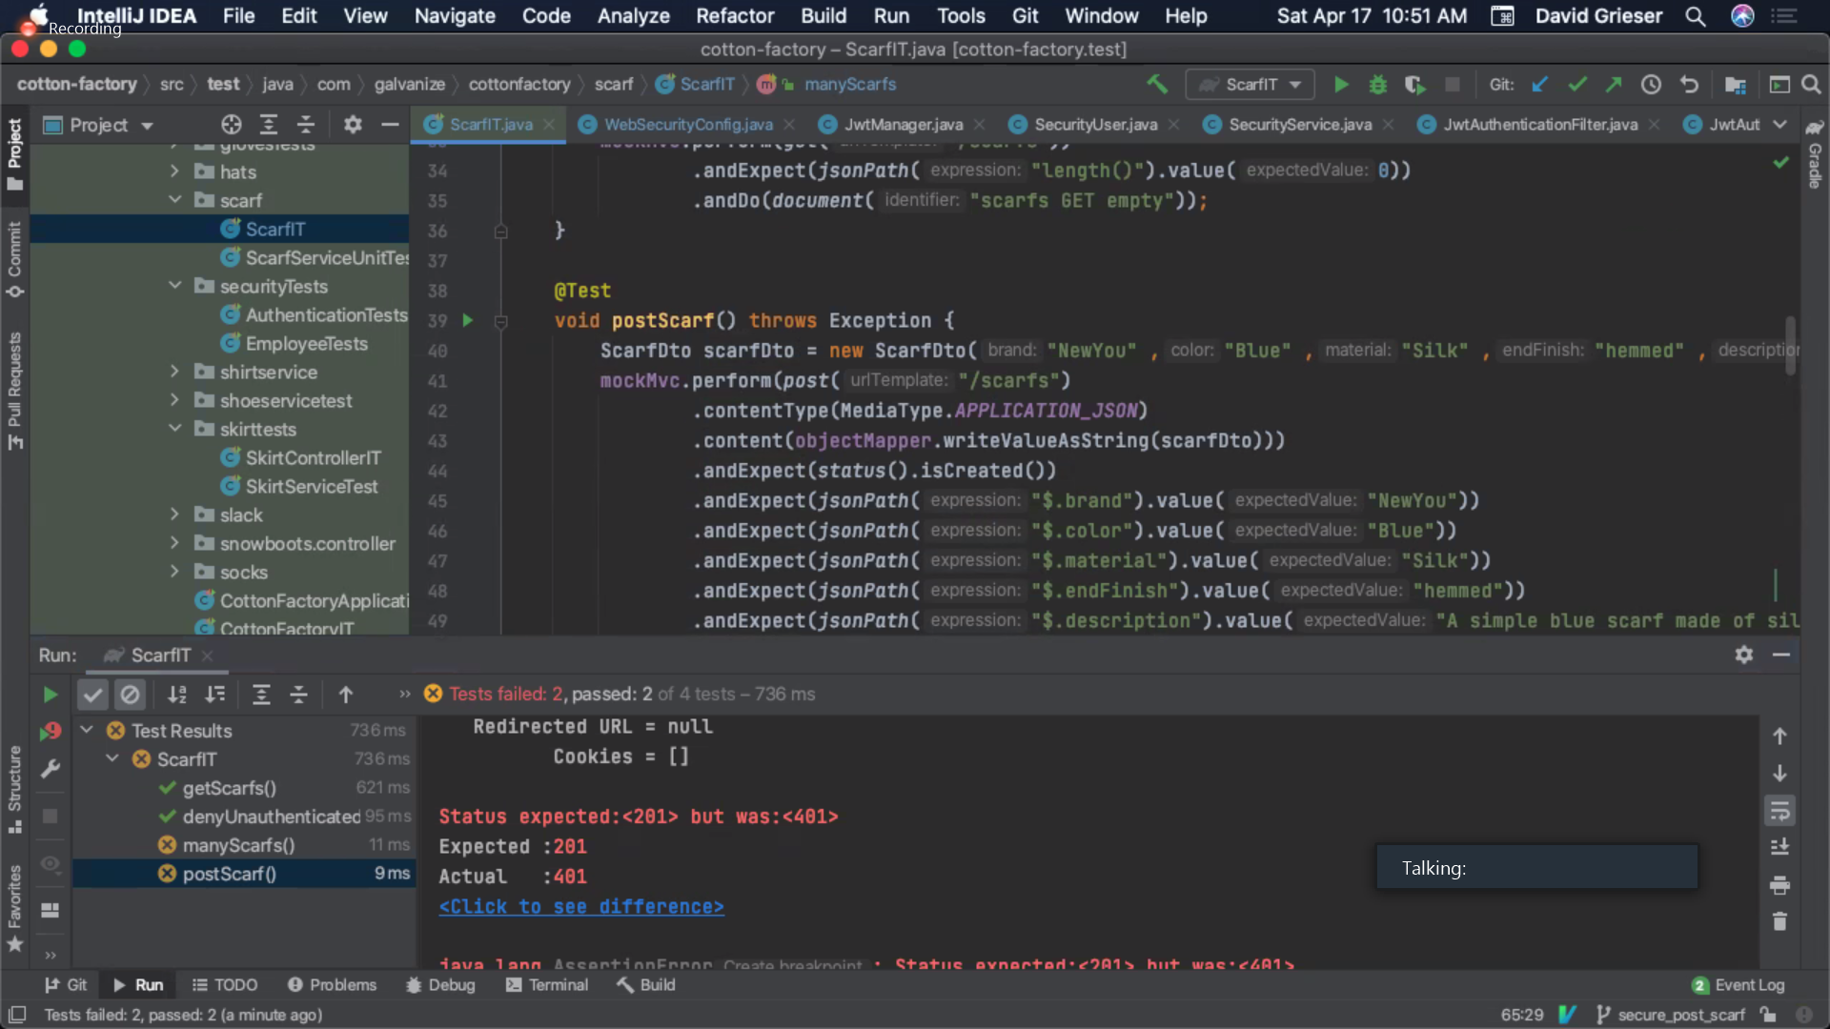

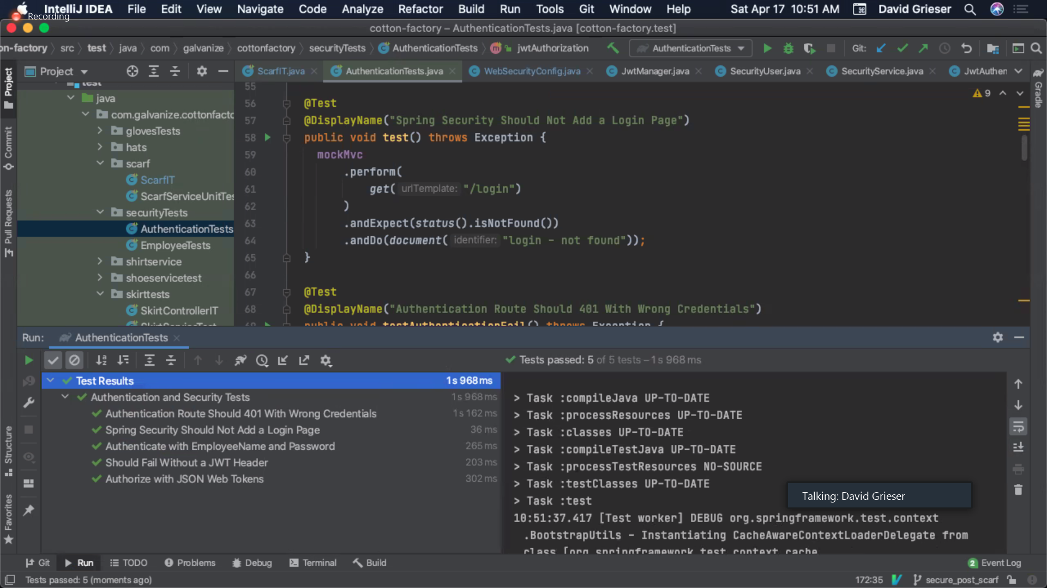

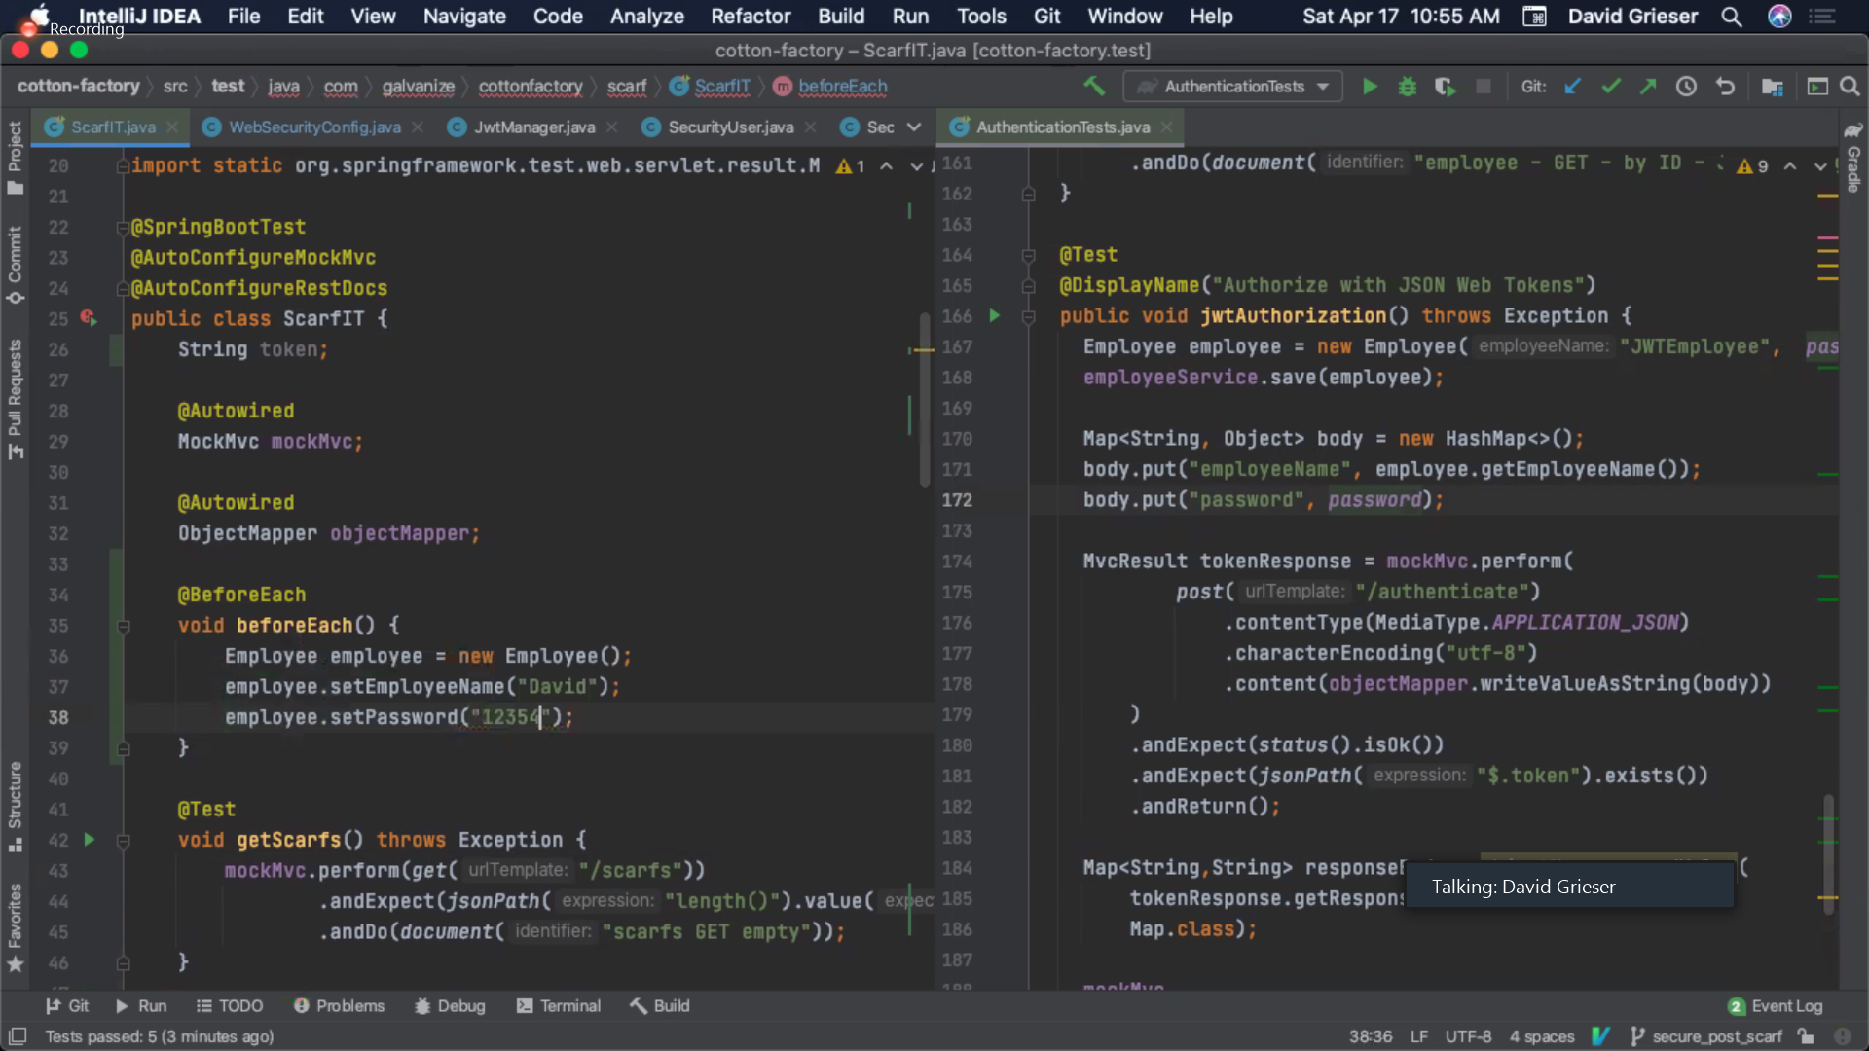

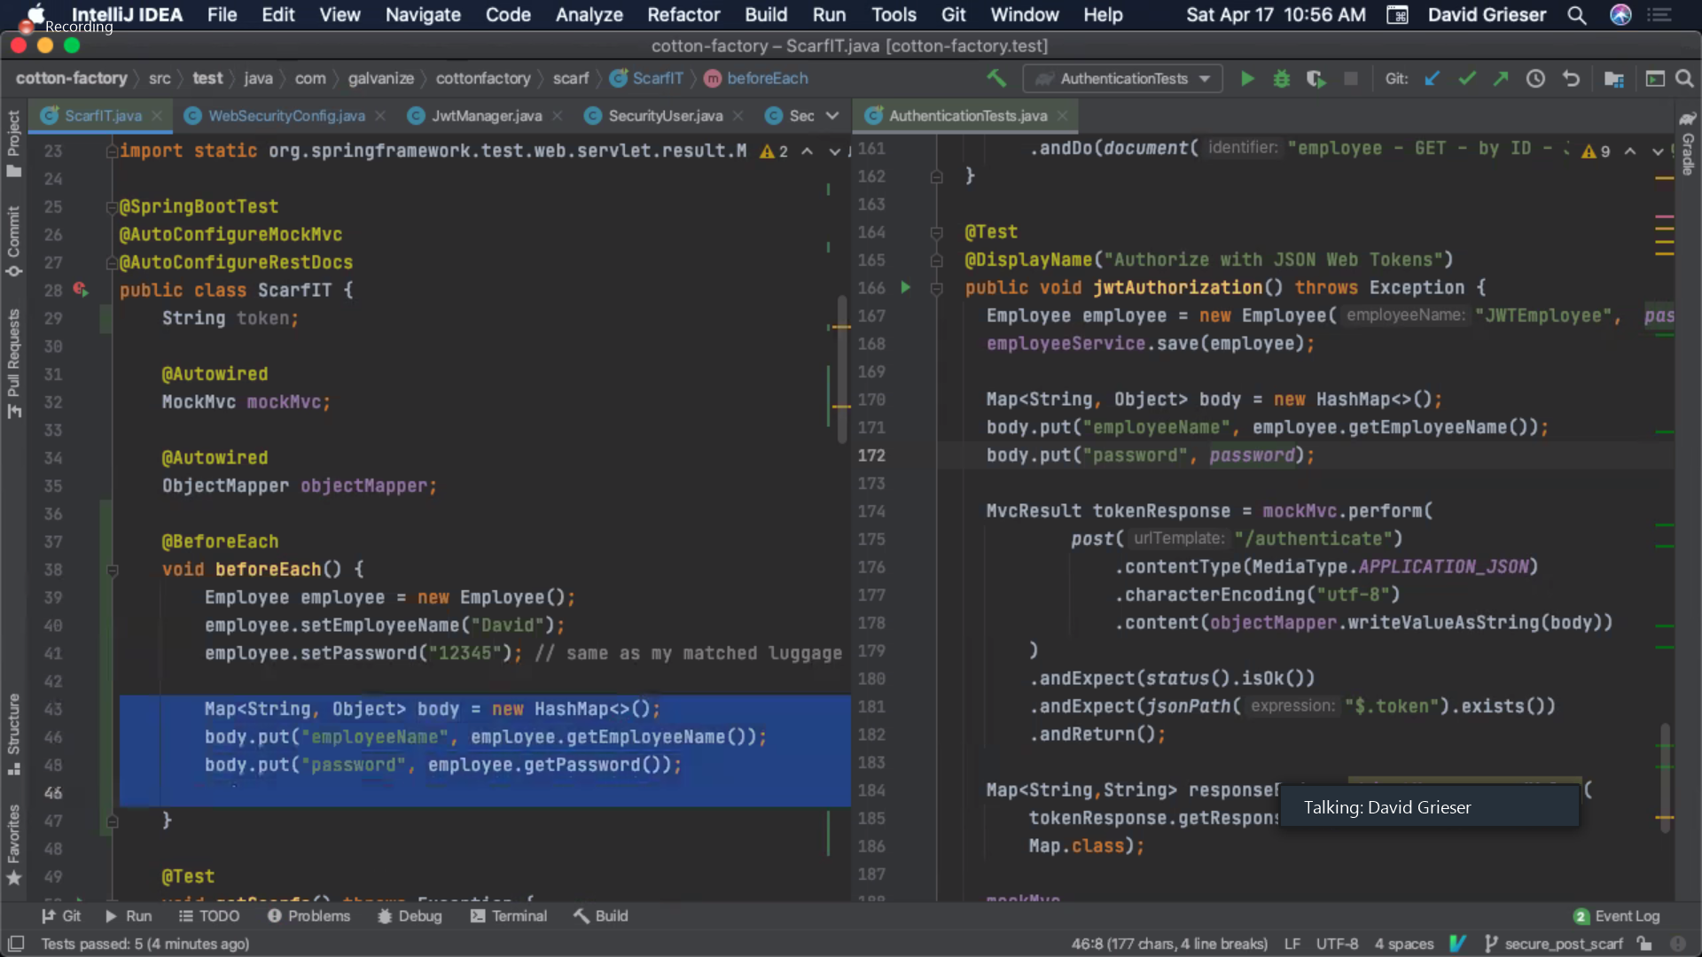

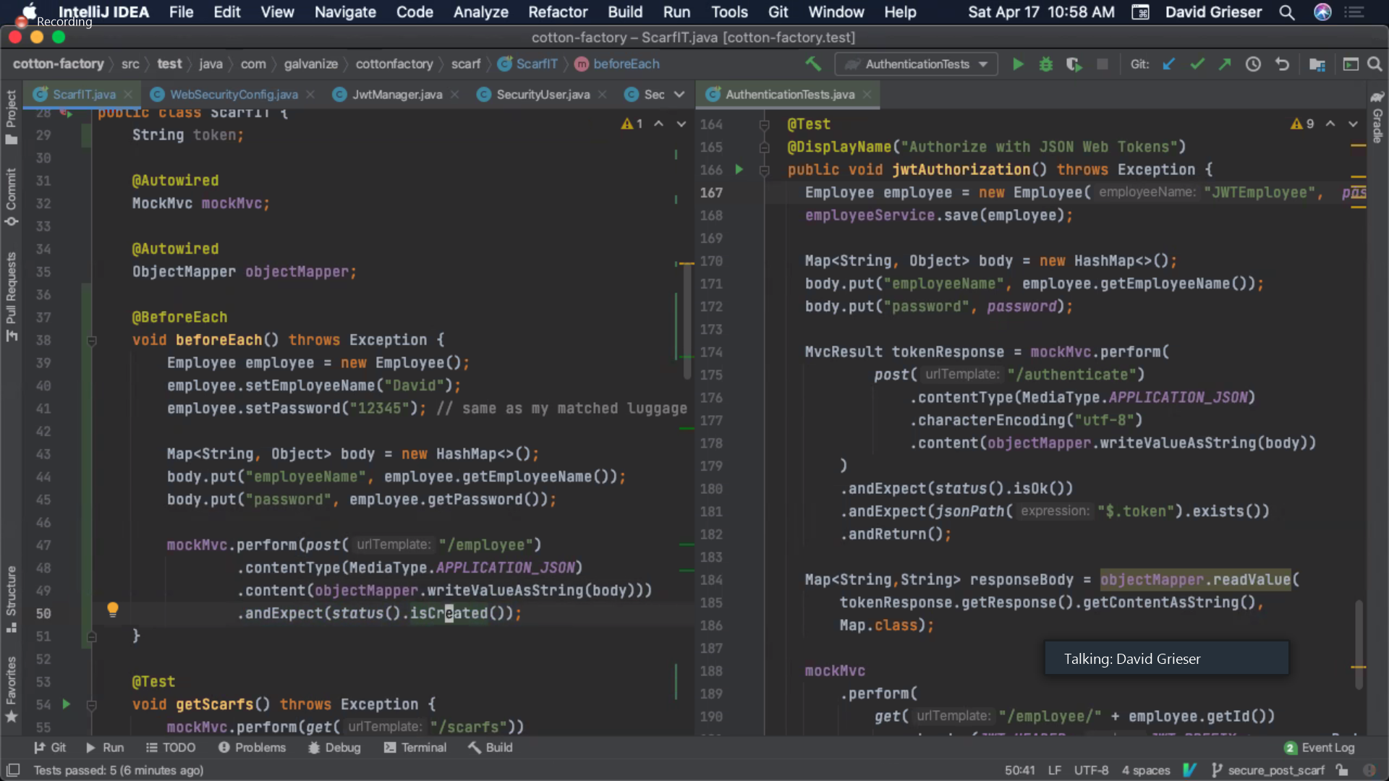

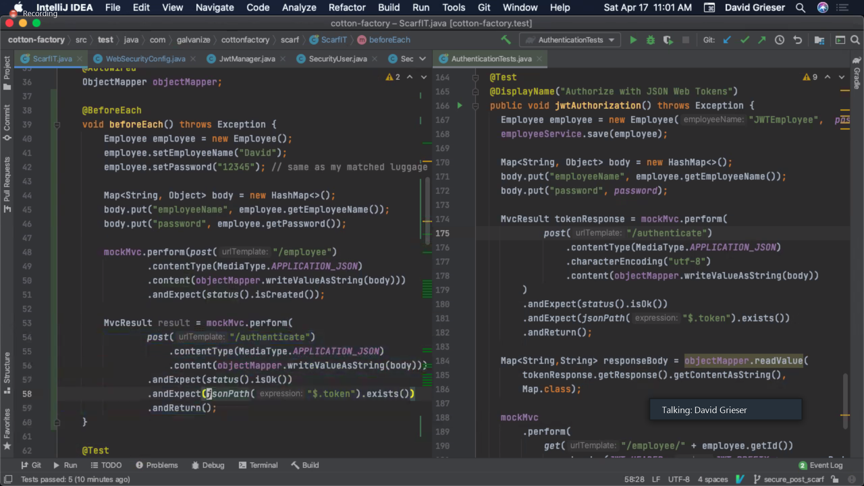

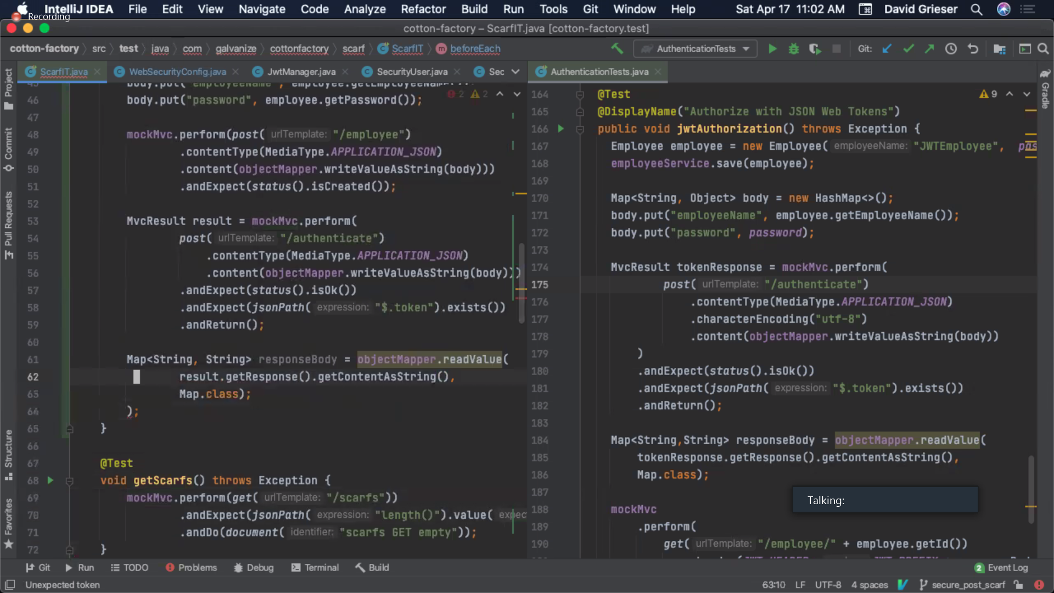

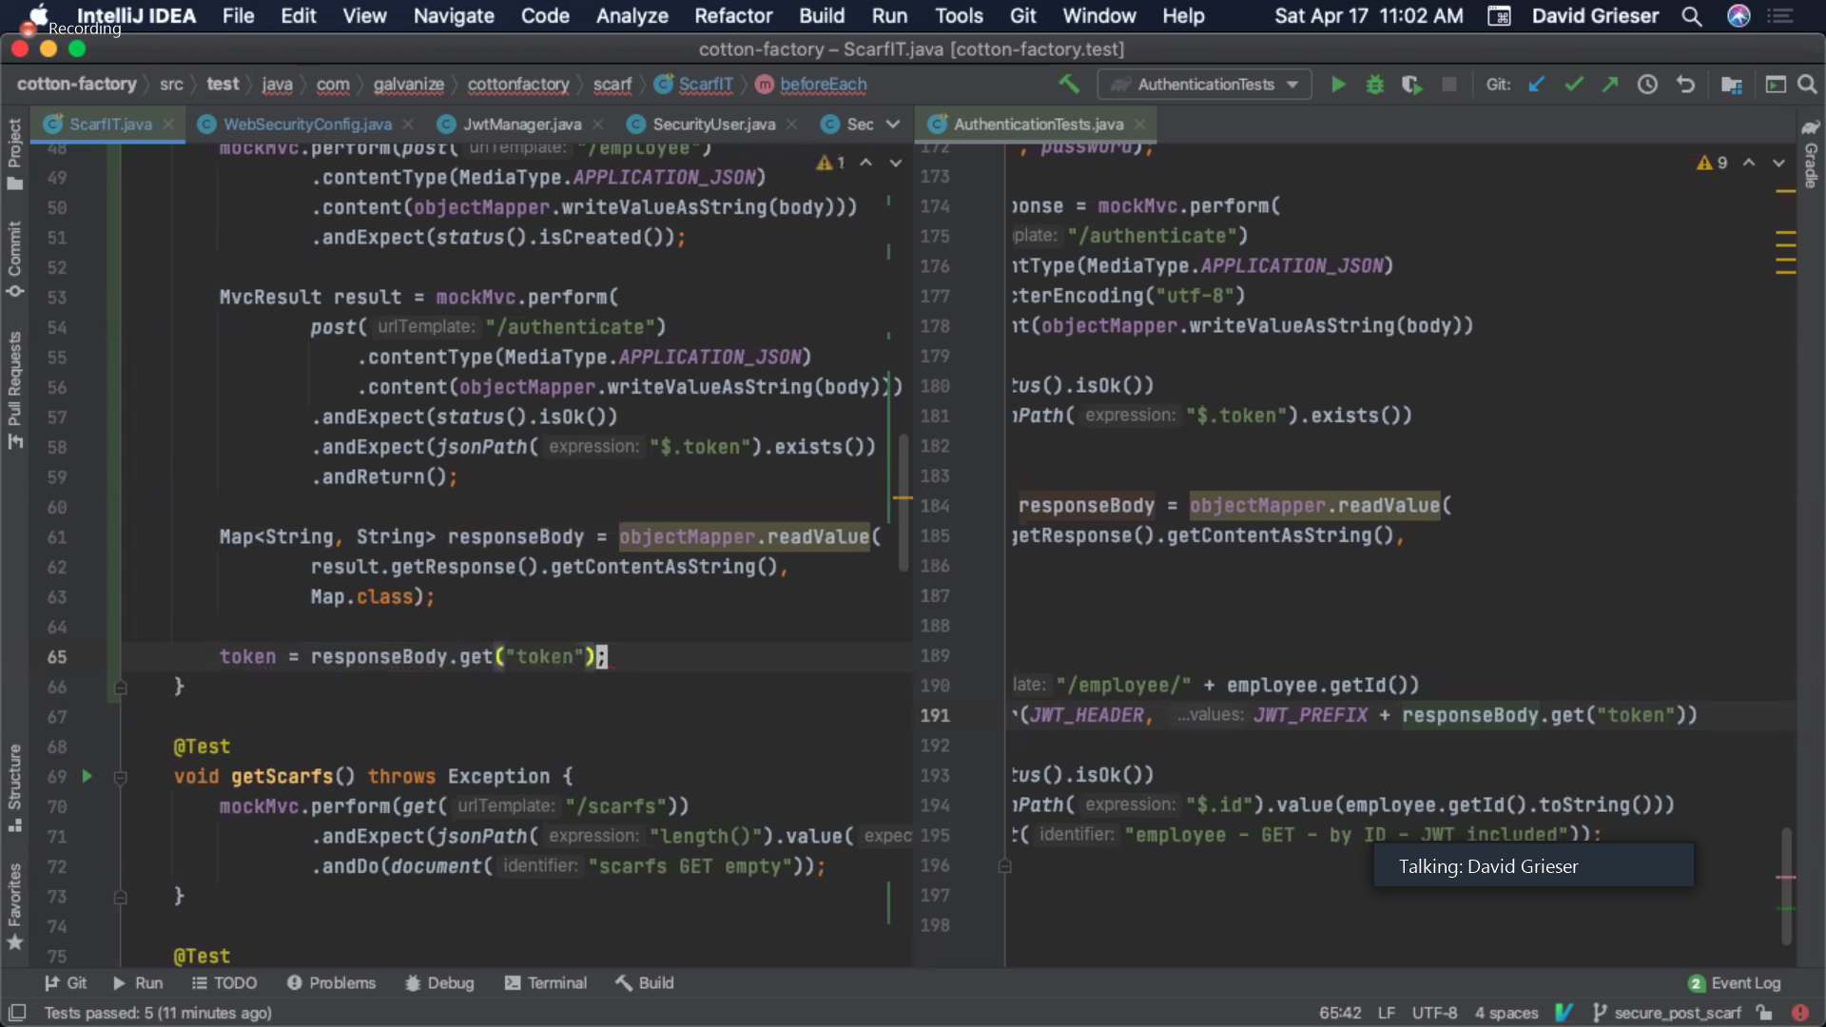

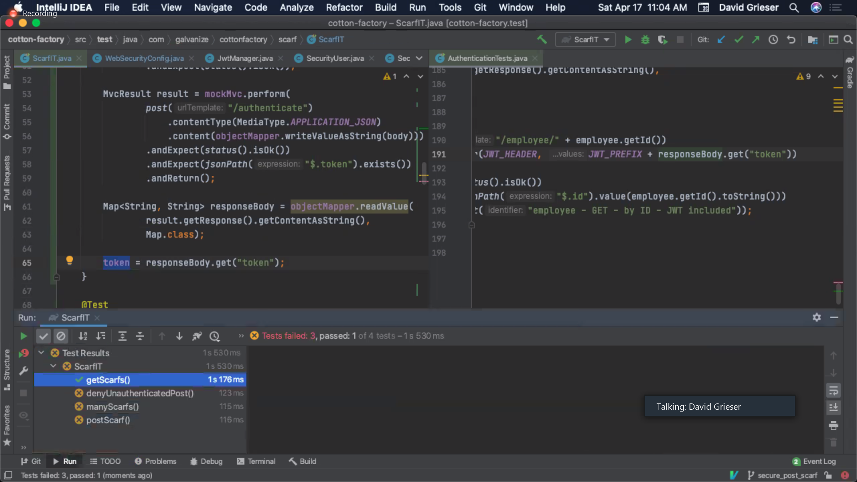

@Transactional

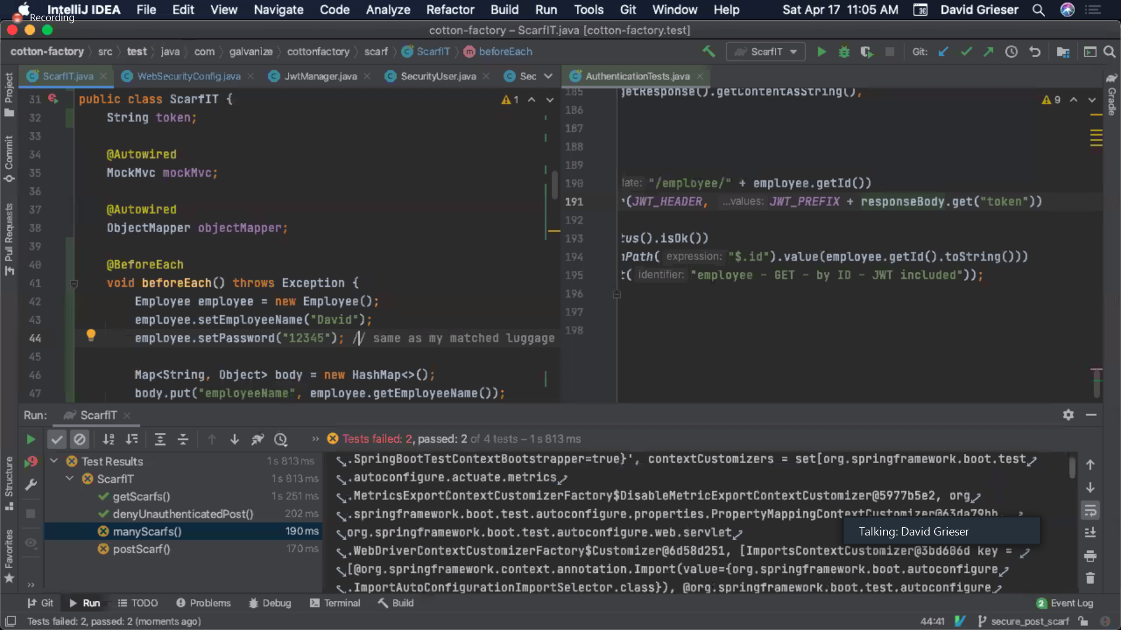

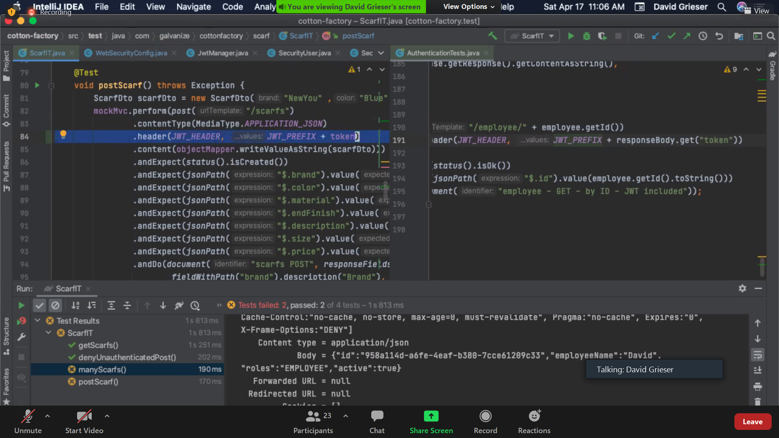

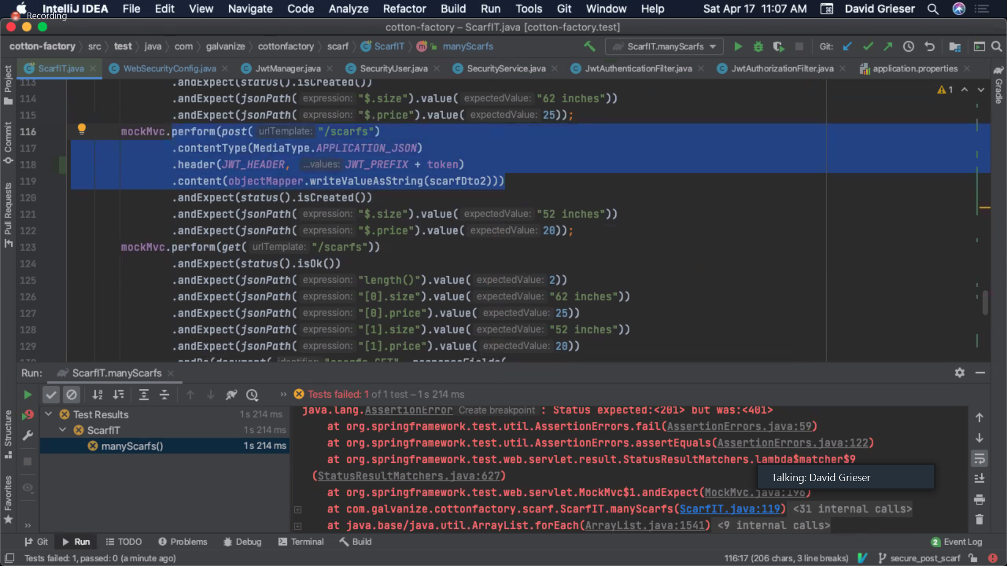

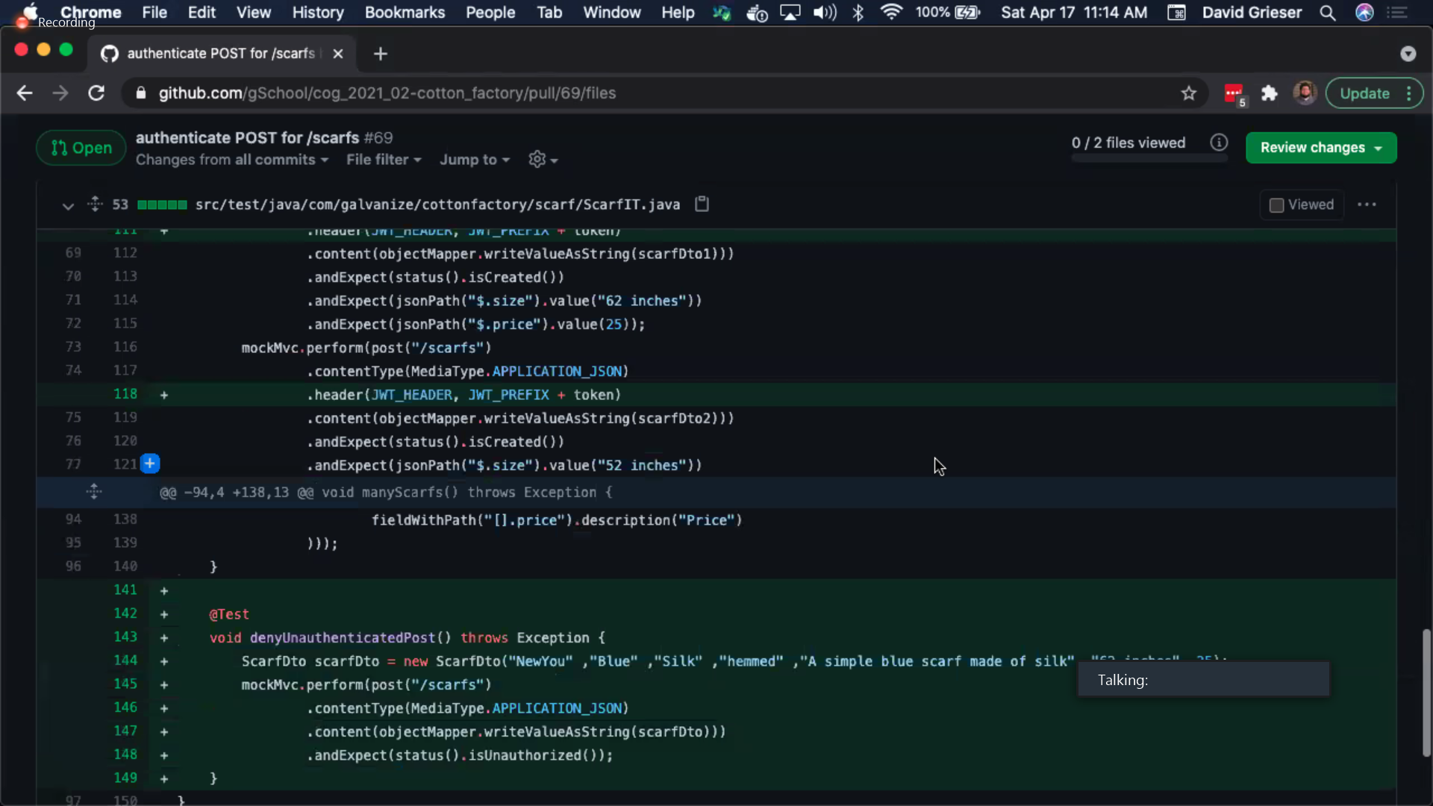

Monday clas

